- Database management system (DBMS)
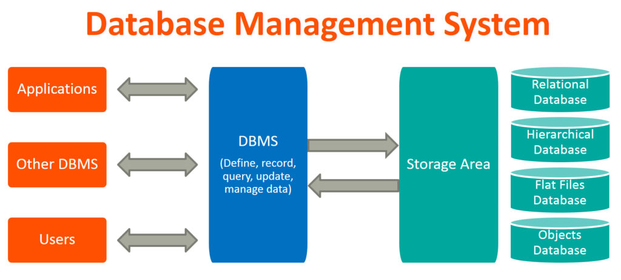
A Database Management System (DBMS) is a software that is used to manage the Database. It receives instruction from a Database Administrator (DBA) and accordingly instructs the system to make the corresponding changes. These commands are used to load, retrieve or modify existing data from the system. A DBMS also facilitates oversight and control of databases, enabling a variety of administrative operations such as performance monitoring, tuning, and backup and recovery.

- Applications of DBMS
Banking system: For storing the customer info, tracking day-to-day credit and debit transactions, generating bank statements, etc.
Telecom: there is an information to keeps track of the knowledge relating to calls created, network usage, client details etc.
While not the information systems, it is laborious to take care of that vast quantity of knowledge that keeps change each time unit.
Airlines: To travel through airlines, we make early reservations; this reservation information along with flight schedule is stored in the database.
Manufacturing: It is used for the management of the supply chain and for tracking the production of items.
There is a hell lot amount of inter-related data that needs to be stored and retrieved efficiently.
Online shopping: you want to bear in mind of the web shopping websites like Amazon, Flipkart etc.
These sites store the merchandise info, your addresses and preferences, credit details and supply you the relevant list of merchandise supported your question.

